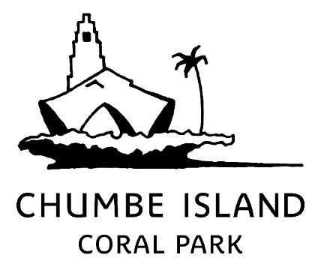
PRESS RELEASE

Chumbe Island Winner of the Best Ethical Wildlife Experience in Africa Award
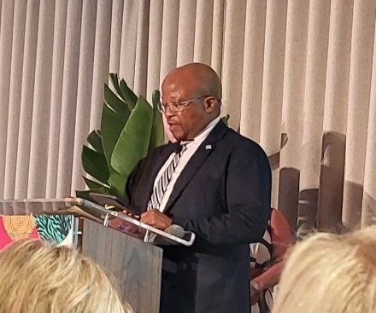
LONDON, 01 July 2024 — At the inaugural ATTA® for Action Awards, Chumbe Island Coral Park in Zanzibar, Tanzania was awarded as the top destination in Africa for providing an ethical wildlife experience, educating tourists and demonstrating significant contribution to natural habitat conservation.
His Excellency Dr. John G. Ndebele Seakgosing, Botswana High Commissioner to the United Kingdom presented the award to the Chumbe Team at a prestigious ceremony as part of the ‘Experience Africa’ trade show. This record-breaking event for the African travel industry was attended by more than 600 participants from 37 countries, showcasing the growing global interest in African tourism.
The ATTA® for Action Awards are designed to recognise and celebrate companies that have demonstrated exceptional commitment to sustainable and responsible tourism practices in Africa.
On the announcement of Chumbe as the winner, the Judge’s commented: “The impact of the efforts of Chumbe Island Coral Park (CHICOP) is evident in its successful conservation outcomes and community benefits. The park has achieved significant biodiversity preservation with high densities of fish and coral species. Studies have shown the effectiveness of the spillover effect, which benefits local fisheries. The park's initiatives have also led to improved livelihoods for community members and greater environmental awareness. CHICOP's model of sustainable park management, funded by ecotourism, serves as an exemplary case for conservation efforts globally.”
Chumbe Island Coral Park is a private island off the coast of Zanzibar, Tanzania, and is a social non-profit enterprise. Established in 1992, CHICOP is famous for turning Chumbe Island’s coral reefs and forest into a fully managed internationally recognised nature reserve, creating the world’s first privately managed marine park that’s fully financed through ecotourism.
Speaking at the event, Chumbe’s Co-Director, Eleanor Carter, stated: “We are excited to receive this award, and showcase once again the leading role that Zanzibar, Tanzania has on the world stage for advancing the Blue Economy.” Chumbe’s investment model has shown the world that it is possible to use business principles to advance social and environmental sustainability. “It is a credit to the Revolutionary Government of Zanzibar in supporting this exceptional approach to coupling investment with social development and environmental preservation.” Carter said.

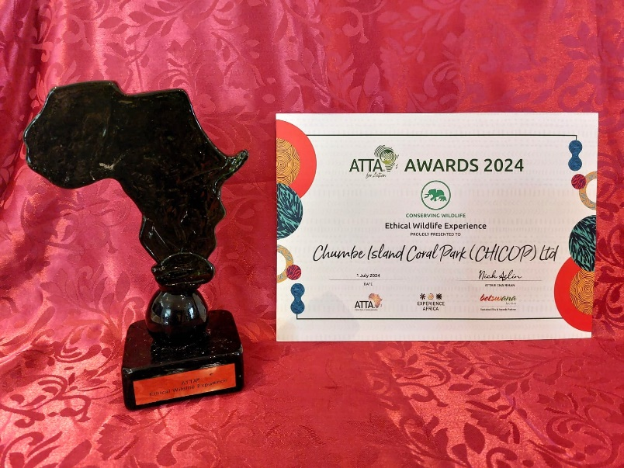

FOR MORE INFORMATION:  Contact: Katinka Kunze  Office: +255 (0) 777 413 232  Email: marketing@chumbeisland.com  www.chumbeisland.com   | Chumbe Island is an internationally acclaimed conservation area, hosting a fully protected coral reef sanctuary and forest reserve.  As a not-for-profit enterprise, the revenue generated by eco-tourism on the island funds all conservation management and supports Chumbe’s extensive environmental education programmes with local schools and communities in Zanzibar.  Operational for nearly 30 years, Chumbe is the world’s first financially self-sustaining marine protected area.

